IUPUI Staff CounciL

Annual Report 2019-2020

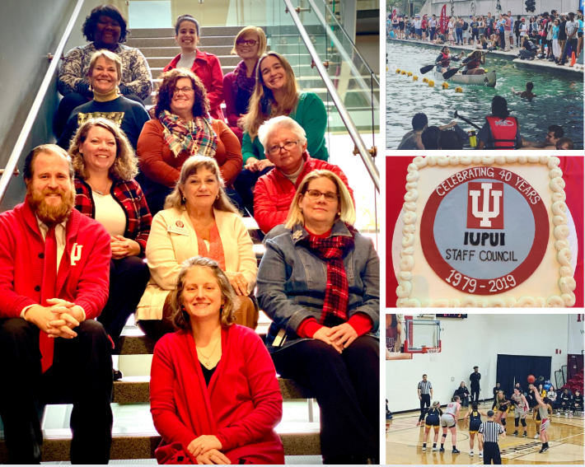

Our communications committee really stepped up this year to make some positive changes for the Council. They created a Salesforce account, updated social media guidelines, set up Hootsuite account to manage social media accounts, created a proposal to add Staff Council to the One.IU website and promoted the Council through various communications avenues (Inside IUPUI, Jagnews, social media). Our other committees didn’t have much time to make any progress due to the Pandemic. We were grateful to continue our meetings remotely and bring campus updates to the staff.

Kristy Beach, President IUPUI Staff Council
IUPUI Staff Council
Representing ALL staff
at IUPUI
for the betterment
of our institution, our city,
our state
and our nation.
Representing ALL staff
at IUPUI
for the betterment
of our institution, our city,
our state
and our nation.

Purpose of the Staff Council
The purpose of the Staff Council at Indiana University-Purdue University Indianapolis shall be to represent the staff in the communication processes and the decision making of the University and
- to increase the sense of identity, recognition and worth of each staff member in his/her relationship to the University,
- to identify concerns relating to staff and to seek their solutions,
- to provide a channel of communication for staff with administration and faculty,
- to promote staff development and to recommend policies which aid in retaining highly-qualified personnel,
- to integrate the staff into campus governance and existing University affairs,
- to establish and promote University-wide activities, publications, work-shops, and seminars, and
- to serve as a resource for other schools or units in the development of School or Unit Staff Councils.

IUPUI Staff Council Constitution and Bylaws Article I

2019-2020 Staff Council Executive Committee

Kristy Beach, President
Aimee Brough, First Vice President
Lindsey Mosier, Second Vice President
Beth Chaisson, Corresponding Secretary
Teresa McCurry, Parliamentarian

Members-at-Large

Mansi Singh Allison Wheeler
Alicia Gahimer Kaitlin Bell
Dave Hanson Heather Staggs
Accomplishments

- Staff Council celebrated their 40th Anniversary, 1979-2019, while IUPUI was concluding their 50th birthday yearlong celebration.
- Held the Annual Staff Council Retreat at Newfields in the Deer Zink Pavilion. Our keynote speaker was Katie Chattin, IU Assistant Curator of Campus Art.
- Had a booth at the Health and Benefits Fair in November where postcards were collected and prizes were awarded. Recorded # of attendees this year, over 600.
- Unit elections were held in April with 14 representatives being elected, of which 10 are brand new to the council.
- Staff Council, Finance and Administration and the Office of Diversity, Equity, and Inclusion jointly sponsorsed the IUPUI Staff Mentoring Programs third cohort.
- Awarded 20 development grants to staff members for professional growth between the August and December rounds. We were unable to accept any applications for the April round due to the COVID-19 pandemic.
- The Staff Development Mini-Conference was scheduled for May 22, 2020 with the theme of: “2020 Vision: Leading from the Inside Out”. Unfortunately, due to the COVID-19 pandemic the conference was cancelled.

Civic Engagement
- Held blood drives in July and October. We were unable to hold our April drive due to the COVID-19 pandemic.
- Continued our support of Paws Pantry with another yearlong service project of stocking 2 shelves with donated breakfast and hygiene items.
- Organized a winter service project with Christamore House collecting wish list items to provide help for those in need.
- Provided sponsorship with ads and attendance of several diversity related organizations in the community for the Harvey Milk dinner, MLK Dinner, and the Cesar Chavez Hispanic dinner. The latter was cancelled due to the COVID-19 pandemic.
- Held a Staff Council Night at a Men’s and Women’s Basketball Game. Thank you to Camy Broeker for providing snacks for SC representatives during the games.
- Entered a Staff Council team “SC Crew” in the Regatta for the 3rd year in a row and placed 61st in the co-ed division. Thank you to Camy Broeker for sponsoring our crew!

Applauding Excellence
On October 8, 2019, the Council celebrated staff on their years of service to the IUPUI campus and collaborated with Jamie Owens in Finance and Administration to host the Chancellor’s Staff Recognition Ceremony. The following awards were handed out through the work of the Staff Council Rewards and Recognition Committee:

- Carol D. Nathan Staff Council Scholarship for the 2019-2020 school year to Chris Dobbs (Music & Arts Technology) and Abby Rolland (School of Philanthropy).
- Glen W. Irwin, Jr., M.D. Experience Excellence Award to Lois Shuman (School of Medicine) and Deborah Stombaugh (School of Medicine).
- Gerald L. Bepko Staff Council Spirit Award to Derek Savick (Office of Student Employment), Kathy Grove (Office for Women), and Dezra Despain (Graduate School).
- Nan Bohan Community Engagement Award to Sara Griffin (Kelley School of Business).

The council also celebrated their own through three internal awards given at the annual retreat. The awards were given by the Staff Council Rewards and Recognition committee as follows:

- Outstanding Committee Chair awarded to Patti Holt (School of Medicine). Co-Chair of the Staff Development Committee.
- Outstanding New Member awarded to Tricia O’Neil (Liberal Arts).
- Member of the Year awarded to Lindsey Mosier (School of Medicine).

Continuing the Work

- Continuing our support of IUPUI Athletics as a Bronze Level sponsor with a 2-year contract.
- Will continue to promote the Staff Council through the Health and Benefits Fair.
- Planning blood drives for 2019-2020 year. The first one was July 17, 2019.
- Planning the annual Staff Council Retreat that will take place in October, 2020 at the Indianapolis Zoo.
- Will continue to support the annual heritage dinners (Harvey Milk, Martin Luther King, Cesar Chavez, Asian Heritage) as support of Diversity, Equity and Inclusion on campus.
- Honoring those who are the Spirit of IUPUI, through the Gerald Bepko Spirit Award, Nan Bohan Community Engagement Award, and the Glenn W. Irwin Experience Excellence awards that are handed out each year at the Chancellor’s Staff Recognition Ceremony. We also give a Carol Nathan scholarship to one or two employees who are continuing their education here at IUPUI.
- The Staff Council bylaws will continue their revisions until completion.
- The Staff Development Committee will continue to provide professional development opportunities for staff.
- Planning for the 2021 Staff Development Mini Conference. This year’s theme will be incorporated into next year’s conference.

2019-2020 Staff Council Committee Chairs
Bylaws – Teresa McCurry
Communications – Heather Staggs
Diversity, Equity and Inclusion – Alicia Gahimer
Faculty Relations – Aaron Fields
Membership – Lindsey Mosier
Rewards and Recognition – Joan Charlesworth
Special Events – Kaitlin Bell and Kris Powell
Staff Affairs – DoMonique Brock
[Ad hoc] Staff Development – Alicia Gahimer (PD Grants), Jeff Creasser, Patti Holt, and
Leslie Albers (PD Mini-Conference)
[Ad hoc] Sustainability – Becki Myers

