IUPUI Staff CounciL

Annual Report 2020-2021

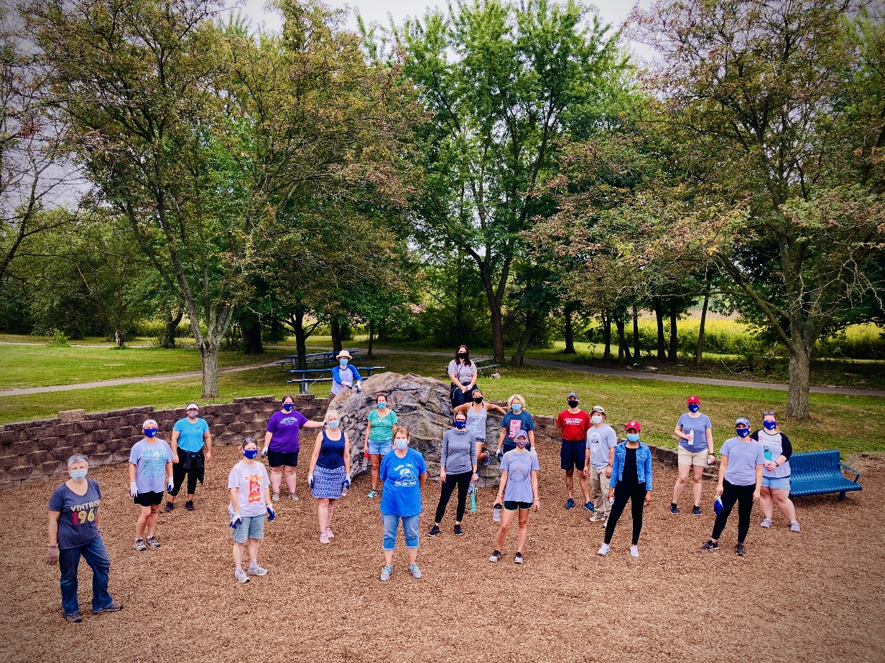

The committee chairs and Council members really stepped up to get their committees to have some focus areas even while most were still remote during this academic year. The Bylaws committee made great strides in the revision/updates to the SC Bylaws. There will be continued focus for the coming year. The Communications committee added SC to the IU Events calendar, relaunched the Random Acts of Kindness and continued to make social media a priority. The DEI committee sent out a survey to determine action items, collaborated with the Calendar Support Team to share learning resources, planning a Diversity Speaker Series for fall 2021. The Faculty-Staff Relations committee met with representatives from Human Resources to provide more bias training for all employees, met monthly with Stephen Hundley to discuss and provide feedback on “Issues and Opportunities for Post-Pandemic Planning” and continued discussion on communication across campus. The Professional Development committee is planning an online “mini-conference” for fall 2021 and a traditional conference in Spring 2022. The pandemic greatly impacted any in-person events. The Rewards and Recognition committee presented the following awards at our annual retreat: Staff Council Outstanding Committee chair, Outstanding New Member and Member of the Year. Fun awards were also given this year related to the pandemic: Best/Worst Zoom fail story, Best save of an event/meeting and funniest location. The Special Events Committee resumed virtual blood drives (encouraging staff to donate at their closest blood center), the holiday party was conducted over Zoom with a cozy blanket being delivered to all reps as a thank you for their hard work, fun activities were added to the monthly meetings (scavenger hunts, trivia games, word scrambles and more). The 2020 annual retreat was cancelled however the . The Staff Affairs committee received approval for Election Day PTO and are working on PTO Sharing and Volunteer Hours PTO. The Sustainability Committee meets regularly with the Office of Sustainability and the Carbon Neutrality resolution was passed. They also reached out to other Staff Council presidents to encourage them to pass the resolution. They have contributed three pieces to the Sustainability newsletter.

In despite of the pandemic, the committees really pulled together to make some much needed progress. It felt very rewarding to end my last term as President with so many accomplishments.
Kristy Beach, President IUPUI Staff Council
IUPUI Staff Council
Representing ALL staff
at IUPUI
for the betterment
of our institution, our city,
our state
and our nation.
Representing ALL staff
at IUPUI
for the betterment
of our institution, our city,
our state
and our nation.

Purpose of the Staff Council
The purpose of the Staff Council at Indiana University-Purdue University Indianapolis shall be to represent the staff in the communication processes and the decision making of the University and
- to increase the sense of identity, recognition and worth of each staff member in his/her relationship to the University,
- to identify concerns relating to staff and to seek their solutions,
- to provide a channel of communication for staff with administration and faculty,
- to promote staff development and to recommend policies which aid in retaining highly-qualified personnel,
- to integrate the staff into campus governance and existing University affairs,
- to establish and promote University-wide activities, publications, work-shops, and seminars, and
- to serve as a resource for other schools or units in the development of School or Unit Staff Councils.

IUPUI Staff Council Constitution and Bylaws Article I

2020-2021 Staff Council Executive Committee

Kristy Beach, President
Lindsey Mosier, President-Elect
Heather Staggs, First Vice President
Alicia Gahimer, Second Vice President
Beth Chaisson, Corresponding Secretary
Teresa McCurry, Parliamentarian

Members-at-Large

Mansi Singh Jeff Creasser
Kaitlin Bell Kylee Sutton
Dave Hanson Javier Barrera
Accomplishments

- Staff Council celebrated their 40th Anniversary, 1979-2019, while IUPUI was concluding their 50th birthday yearlong celebration.
- Held the Annual Staff Council Retreat at Newfields in the Deer Zink Pavilion. Our keynote speaker was Katie Chattin, IU Assistant Curator of Campus Art.
- Had a booth at the Health and Benefits Fair in November where postcards were collected and prizes were awarded. Recorded # of attendees this year, over 600.
- Unit elections were held in April with 14 representatives being elected, of which 10 are brand new to the council.
- Staff Council, Finance and Administration and the Office of Diversity, Equity, and Inclusion jointly sponsorsed the IUPUI Staff Mentoring Programs third cohort.
- Awarded 20 development grants to staff members for professional growth between the August and December rounds. We were unable to accept any applications for the April round due to the COVID-19 pandemic.
- The Staff Development Mini-Conference was scheduled for May 22, 2020 with the theme of: “2020 Vision: Leading from the Inside Out”. Unfortunately, due to the COVID-19 pandemic the conference was cancelled.

Civic Engagement
- Held blood drives in July and October. We were unable to hold our April drive due to the COVID-19 pandemic.
- Continued our support of Paws Pantry with another yearlong service project of stocking 2 shelves with donated breakfast and hygiene items.
- Organized a winter service project with Christamore House collecting wish list items to provide help for those in need.
- Provided sponsorship with ads and attendance of several diversity related organizations in the community for the Harvey Milk dinner, MLK Dinner, and the Cesar Chavez Hispanic dinner. The latter was cancelled due to the COVID-19 pandemic.
- Held a Staff Council Night at a Men’s and Women’s Basketball Game. Thank you to Camy Broeker for providing snacks for SC representatives during the games.
- Entered a Staff Council team “SC Crew” in the Regatta for the 3rd year in a row and placed 61st in the co-ed division. Thank you to Camy Broeker for sponsoring our crew!

Applauding Excellence
On October 8, 2019, the Council celebrated staff on their years of service to the IUPUI campus and collaborated with Jamie Owens in Finance and Administration to host the Chancellor’s Staff Recognition Ceremony. The following awards were handed out through the work of the Staff Council Rewards and Recognition Committee:

- Carol D. Nathan Staff Council Scholarship for the 2020-2021 academic year to Jerry Mooney (Engineering & Technology) and Cathie Carrigan (School of Philanthropy).
- Glen W. Irwin, Jr., M.D. Experience Excellence Award to Sydni Thomas (School of Medicine) and Emily Hunnicutt (University College).
- Gerald L. Bepko Staff Council Spirit Award to Tanner Hammock (School of Liberal Arts), Brooke Moreland (School of Education), and Jennifer Mahoney (Graduate School).
- Nan Bohan Community Engagement Award to Niki Messmore (School of Medicine).

The council also celebrated their own through three internal awards that are typically handed out at the annual retreat. This year we were unable to hold our in-person retreat. So, we held a special meeting in July. The following awards were given by the Staff Council Rewards and Recognition committee as follows:

- Outstanding Committee Chair awarded to Heather Staggs (Finance and Administration). Chair of the Communications Committee.
- Outstanding New Member awarded to Leslie Albers (VP for Research).
- Member of the Year awarded to Kristy Beach (School of Dentistry).

Continuing the Work

- Continuing our support of IUPUI Athletics as a Bronze Level sponsor with a 2-year contract.
- Will continue to promote the Staff Council through the Health and Benefits Fair.
- Planning blood drives for 2019-2020 year. The first one was July 17, 2019.
- Planning the annual Staff Council Retreat that will take place in October, 2020 at the Indianapolis Zoo.
- Will continue to support the annual heritage dinners (Harvey Milk, Martin Luther King, Cesar Chavez, Asian Heritage) as support of Diversity, Equity and Inclusion on campus.
- Honoring those who are the Spirit of IUPUI, through the Gerald Bepko Spirit Award, Nan Bohan Community Engagement Award, and the Glenn W. Irwin Experience Excellence awards that are handed out each year at the Chancellor’s Staff Recognition Ceremony. We also give a Carol Nathan scholarship to one or two employees who are continuing their education here at IUPUI.
- The Staff Council bylaws will continue their revisions until completion.
- The Staff Development Committee will continue to provide professional development opportunities for staff.
- Planning for the 2021 Staff Development Mini Conference. This year’s theme will be incorporated into next year’s conference.

2020-2021 Staff Council Committee Chairs
Bylaws – Tricia O’Neil
Communications – Heather Staggs
Diversity, Equity and Inclusion – Julie Garringer
Faculty Relations – Aaron Fields
Membership – Alicia Gahimer
Rewards and Recognition – Beth Chaisson
Special Events – Kaitlin Bell
Staff Affairs – Dave Hanson
Staff Development – Alicia Gahimer (Grants), Jeff Creasser and Leslie Albers (Mini-Conference)
Sustainability – Mindy Cooper

