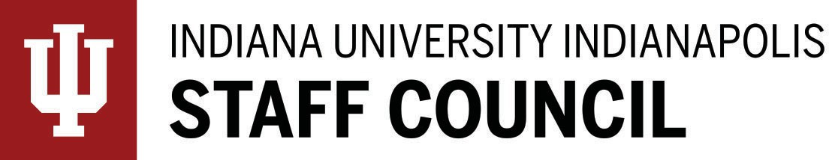

Staff Council Meeting

Minutes 12/17/25

In-person Meeting

Members and Guests Present: Leslie Albers, Sadiya Ali, Brayden Bridgeman, Camy Broeker, Ainsley Brown, Aaron Buck, Esther Calderon, Beth Chaisson, Joan Charlesworth, Megan Chester, Crystal Clark, Kimberly Coles, Mindy Cooper, Angela DeCamp, Mel Dumas, Tricia Edwards, Kevin Fryling, Alicia Gahimer, Jennifer Gilles, Lauren Gronke, Alison Hughes for Jill Henry, Lindsay Hughes, Nick Hyllested, Kim Johnson, Amanda Keene, Anne Mitchell, Amber Phillips, Kris Powell, Matthew Radican, Lindsey Sanner, Tanika Scott, Huma Siddiqui, Emily Skoniecke, Dillon Waggoner, Katie Wright, Damaris Galan, Abigail Hotmire, Jesse Lamberton, Violet Salas, Olivia Stoner

Members Absent: Chad Beckner, Barbara Beeker, Thora Berndt, Mary Chappell, Melissa Decker, Chris Dobbs, Roland Graham, Angie Harmon, Lindsay Heinzman, Michael Hernandez, Madi Jones, Cameron Ligocki, Salem Lucas, Ellise Smith, Anita Snyder, Yolanda Taylor, Jordan Wheatley, Catherine Zappia, David Bryant, Cathy Lusch, Sabrina Hetzel, Tammy Pressler, Taylor O’Day, DC Choudhury, Yana Carrasgullen, Jon Fast, H Kaser, Melissa Vastag, Alyssa Scheinder

Members Excused: Andrea Zeek, Todd Grooten, Tammy Leone, Tyler Childress, Billie Jean Barry, Cody Robinette, Doris Muriathiri,

Agenda Item I: Welcome and Call to Order
Tricia Edwards, Staff Council Interim President, trewrigh@iu.edu

IU Indianapolis Staff Council Interim President Tricia Edwards called the meeting to order.

Agenda Item II: Adoption of the Order of Business for the Day
Tricia Edwards

The agenda was adopted as the Order of Business for the Day.

Agenda Item III: Approval of Minutes of the November 19, 2025 SC Meeting
The minutes for November were adopted.

Agenda Item IV: Report from the Interim President
Tricia Edwards

Interim President Report

· Thanks to everyone who participated in the Blood drive. It positively impacted 60 lives!
· Many at the University Holiday Celebration sent kudos for the good work by the Staff Council.
· Megan Watson, Staff Professional Development Grand recipient, attended the 2025 EA Ignite
Conference.
· Staff Award nominations open through February 23rd.
· Tricia Edwards to serve as Interim President. There will be a special election in June.

PROFESSIONAL DEVELOPMENT & INVOLVEMENT OPPORTUNITIES

Upcoming CareTalks – Virtual from 1-2pm
https://events.iu.edu/iuhumanrescal/all/tags/Care.com?_gl=1*rnlbwa*_ga*MTI5Mzc3MzcwOS4xNzExNDYyNjU2*_ga_61CH0D2DQW*MTcxMTQ2MjY1Ni4xLjEuMTcxMTQ2MzA2NC42MC4wLjA.

STAFF MILESTONES

November milestones total 34!

Staff Spotlight

Jayme Little
Pablo Sanchez
Pam Hall
Athletic report by Lauren Gronke

Upcoming games

https://iuindyjags.com/calendar

Agenda Item V: Update from Vice Chancellor for Finance & Administration
Camy Broeker, Vice Chancellor, Finance & Administration, cbroeker@iu.edu

- Thank you to all staff! Please keep in mind holiday hours around campus. Anticipate reduced hours. Buildings will be secured. Please take time to unplug.

Agenda Item VI: Update from Human Resources
Anne Mitchell, Senior HR Director, IU Indy Human Resources, amitch29@iu.edu

- Staff should be proud of all the progress made in 2025. Thank you to all staff!

Agenda Item VII: Update from Faculty Council
Dr. Thomas Stucky, Faculty Fellow Undergraduate Research, Professor of Criminal Justice, O’Neill School of Public and Environmental Affairs, tstucky@iu.edu
- Thank you to all the staff from the faculty for your partnership in 2025!
- 2026 will include focus groups and listening sessions.

Agenda Item VIII: Standing Ad Hoc and University Committee Reports
Communications Committee –
- Newsletter distribution planned for January.
- The committee is still looking for individuals to quote.
- Don’t forget to check out the social media.

Membership Committee -
- Special election was conducted for vacancy in Social Work.
- Upcoming special election for vacancy in Med 5.2

Awards and Recognition Committee -
- A reminder to nominate individuals for staff awards!
https://staffcouncil.indianapolis.iu.edu/awards-grants/index.html

Special Events Committee –
- March 4th will be the “Level Up” conference.

Sustainability Committee –
- Power down for break!

Staff Affairs Committee –
- Looking to identify the best way to reach out to constituents.

Agenda Item IX: Question and Answer Period

No questions

Agenda Item X: Unfinished Business

No unfinished business

Agenda Item XI: New Business

No new business

Agenda Item XII: Closing Remarks (to be followed by socializing)
Tricia Edwards

Next Staff Council meeting is January 21, 2026 – University Library 0130 - Lilly Auditorium

With no further business, the meeting was adjourned.
Minutes prepared by Joan Charlesworth, MS 5035 / 274-1673 / jocharle@iu.edu

"Stay connected with us on Instagram  and Facebook "

